Evaluation

I think the purpose of a magazine advert is to attract people to buy your product by putting things that make it eye-catching like vibrant colours and an interesting front cover. The front cover is especially important because if your front cover looks bad and unattractive then people will go off the game and not want to buy it as they will think it looks boring although the game itself is actually good.

I believe my magazine advert achieves all of this because it has vibrant colours like purple, red and green. It attracts my target audience of 14-16 years old because it has a glowing character and background and has a space theme which many teenagers find interesting.

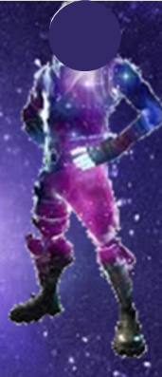

There are many things that worked out well for me. One thing that worked well is finding a main character. I found a character online that perfectly matched my background as the character has a space theme on its body. As you can see, it looks really good with the background because they are both purple and has a glow. “Your character links really well with the background.” -Jawaad

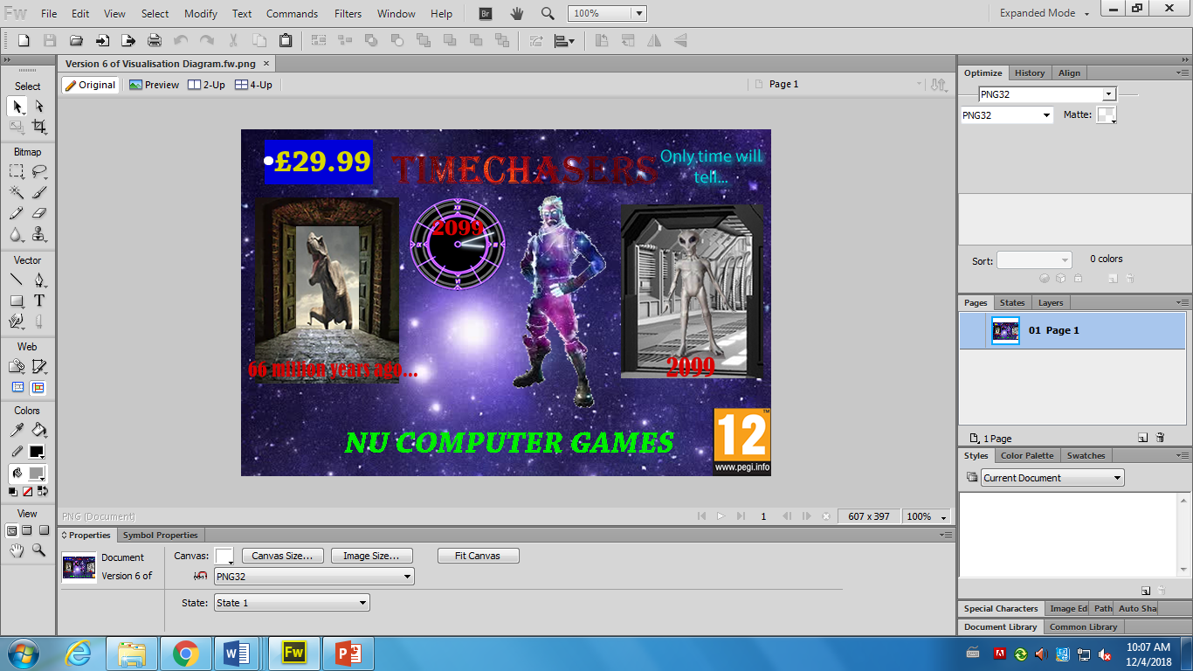Another thing that worked well for me was using the tools in Fireworks. An example of this is when I made the title of the game. I created this title by putting a picture inside the text so the colour of the background is the colour of the text using the Paste Inside function. “Looks good, but change the background colour picture as it is not that clear” –Ali

Throughout the production of the magazine article, I used a variety of saturation, contrast and brightness features to make the product look significantly more appealing to the target audience. For example, the text has a high saturation as I believe the colour of the text looks pure rather than washed out or pale.

Throughout the production of the magazine article, I used a variety of saturation, contrast and brightness features to make the product look significantly more appealing and to the target audience. For example, the text has a high saturation as I believe the colour of the text looks pure rather than washed out or pale.

Another acheivement was using the crop tool and the magic wand tool. I found it quite easy to use the tools as I have previous experience with them so I could take out all the unnecessary parts of the image and keep the useful bits in. if there was still parts that were unneeded like little dots and lines I used the rubber tool to take them out. So editing the image and cropping it I found really simple.

There are also some things that didn’t work so well or I found difficult. One thing I found difficult was meeting the requirements of the client brief. Because the game was for 14-16 year olds, I needed to include a PEGI 14 logo. After further research of this, I learnt that PEGI 14 logo did not exist so I had to choose between a PEGI 12 one or a PEGI 16 one. I chose to go with the PEGI 12 logo because if I did the PEGI 16 one this would mean that 14 and 15 year olds can’t play it. So I included the PEGI 12 one into my magazine advert in the bottom right hand corner.

Also when making the magazine advert I didn’t have all the skills needed to complete the product as there were certain aspects that I wanted to include into the product that I couldn’t do by myself such as putting filters in my texts and backgrounds which I had to research for as I didn’t know how to apply this.

Furthermore, I found following my Gantt chart really difficult because when I tried to complete the tasks, I estimated how long it would take to complete these specific tasks e.g in the ‘Collect any assets and record them into an assets table’ task I estimated it would take 1 hour but I was constantly changing it and adding more assests to it every lesson so it clearly took more than 1 hour. Also, in the ‘Creating the product’ task, I estimated it would take 3 hours, but because there were multiple contingencies like absences and not getting done in class, it took a few weeks to do. I spent too much time focusing on my product and didn’t spend enough time improving my LO1 and LO2 so that was also an issue for me.

* The client brief mentions I need the title of the magazine advert to be TIMECHASERS and price it to £29.99.
* It also mentions that I need to have a watch and a character. “The player has a special Timewatch to help them find the doorways” which I included in my advert.
* Another requirement of the magazine was to have two versions of the final digital graphic. One version must be a “full colour printed magazine” and another version must be “re-purposed for use online.” I did this by creating my magazine advert on Adobe Fireworks and creating the different versions on there too. There was also an option to use Photoshop but I chose not to as I have more experience with Fireworks and I feel it is easier.
* It also said that the character had to go through “doorways.” After I read this I thought I needed to include doors so I included 2 doors: one showing the future and another showing the past.

Personally, I think I did quite good with my product as I think it checks most of the requirements. However, if I was to do it again, I would maybe spend more time with the design of the title. Also, I would spend more time researching for better assets, and I would maybe change the doors a little because I spent less time researching for one as I just found a decent door and put it in my advert. “I think you did quite well too, good job!” -Absar

Furthermore, I would add more slides into the step-by-step guide because I only did 15 and I feel like I should have put more in. I learnt a lot of new skills in Fireworks whilst creating this magazine advert so more slides would have been better but I ran out of time.

There also has been several features that I struggled with. For example, the fact that I was lacking the skills used to make the product. This was because I didn’t have the knowledge to do certain things that the client brief asked me to do so I had to do a little research. For the doors, I researched how to paste images inside shapes. This would be used to make the doors, as the images inside need to be related to time travel. In addition, the doors would initially represent the past and the future.